ISPEED Syllabus

*Mantej Singh (*[*msingh44@jhu.edu*](mailto:msingh44@jhu.edu)*)*

*04/24/2023*

**Objective:**

To provide students with an interactive and hands-on opportunity to build their own microscope using the Raspberry Pi (RPi) platform and image histological, bacterial, and natural specimens. In doing so, students will learn more about optics and microscopy when acquiring images and basics of computer programming as they write code to analyze their images.

**Session 1 (07/06/2023):**

*Focus: Build the RPi microscope and setup the software environment*

75 minutes:

1. Nick/Ji Yi gives a 15-minute overview of microscopy to the students.
2. Students build their own foldscope (design studio).

105 minutes:

1. Teams of 5 students get their own RPi microscope kits.
2. **Hardware:**
   1. Setup connections between camera, power supply and display screen.
   2. Arrange RPi v3 camera and smartphone macro lens configuration.
3. **Optics:**
   1. Learn more about the macro lens design they are using and the lens maker equation.
4. **Software:**
   1. Install Raspian OS onto the RPi system.
   2. Perform initial setup of the OS
      1. Mantej will pre-install the OS on SD Cards so that the students should just plug in the SD card for the install process to begin.
   3. Interface the camera controls using Python’s [PiCamera Library](https://picamera.readthedocs.io/en/release-1.13/)
      1. Involves writing a Python script in an IDE to connect to the camera and read the image data coming from the camera.
      2. At the end of the session, students should be able to open a live preview of their microscope and acquire a single image.
      3. Session 1 ends with all groups ideally having their microscopes setup and being able to acquire a single image through a short python script.

**Completed Microscope Design:**

**Session 2 (07/13/2023):**

*Focus: Program image acquisition and analysis pipeline*

*180 minutes:*

1. Continue working on the PiCamera coding pipeline to ensure that clear images are being acquired.
2. **Optics Theory:**
   1. Students can learn about the lens maker equation and quantify the magnification they are seeing.
   2. They can test the camera and determine the distance the object needs to be from the lens to get an in-focus image.
3. Proceed to acquire images from the provided brain cell slides and tweak imaging parameters as needed (light intensity, exposure, etc).
4. Students can only bring their own specimens of interest to this session to image (e.g swab their own cheek cells).
5. Depending on interests, students can try 3 different tracks:
   1. *Track 1: Mechanical/Electrical Engineering* 
      1. Students can build a more complex stage to help them manipulate their samples with finer control.
   2. *Track 2: Computer Science*
      1. Students explore image filters such as Frangi, Otsu, Edge detection, etc. and incorporate them into their software to further explore image analysis.
   3. *Track 3: Optics*
      1. Students can image their samples under different light sources such as:
         1. Dark field imaging
         2. Imaging with multiple light sources (such as camera flashlights)
         3. Manipulate the exposure settings programmatically.

**Community Building:**

To cement the learning outcomes, I firmly believe that the students should remain engaged with what they’ve built and continue improving it. As part of continual learning and ensuring long term benefits of this program, I will create a Github repository, ISPEED Microscopy, which all students will have access to and will be made public.

In this repository, I will upload all the instructions, details of the parts required and everything students need to be able to recreate the microscope and the code needed to interface with it. To encourage community building and learning from each other, students will be able to post questions, share images they’ve taken and difficulties they run into. I will be routinely monitoring this repository and will help to provide resources and answer their questions.

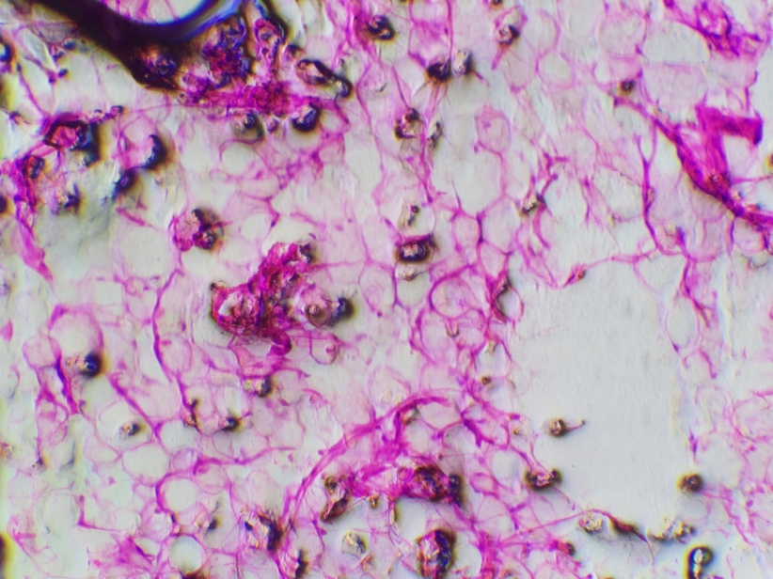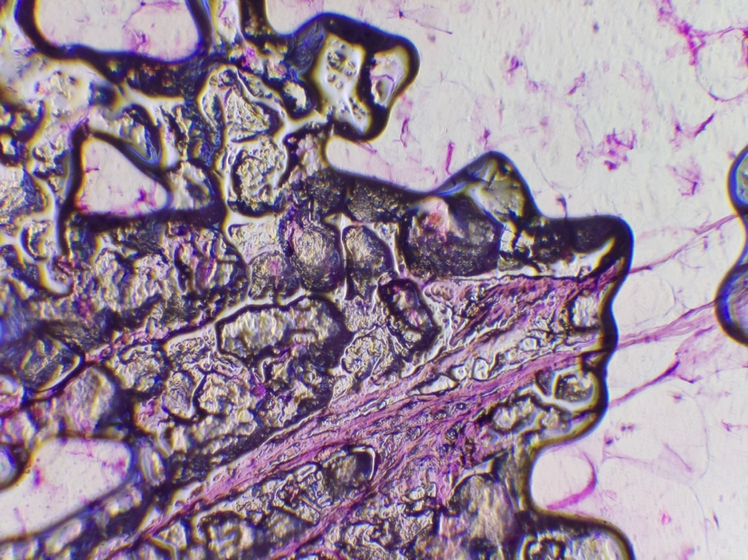**Sample Images taken from the microscope:**

